**Football Academy**

Web programming class project, academic year 2024/2025  
2nd period

|  |  |  |  |  |
| --- | --- | --- | --- | --- |
| Student Name in English | Student Name in Arabic | Student ID | Section time as shown in zajel | Work percentage |
| Amjad Mousa | ادم عباهره | 121113269 | 8-9.5 | 50% |
| Yazan Saleh | محمد جدوع |  | 8-9.5 | 50% |
|  |  |  |  |  |

---------------------------------------------This section is intended for the Instructor---------------------------------------

|  |  |
| --- | --- |
| **Topic** | **Mark** |
| Project Idea |  |
| Project Complexity |  |
| Project Tools |  |
| Project Requirements and Modeling |  |
| Project Discussion |  |
| Project Completeness |  |
| Project Output Results or reporting |  |
| Project Administration and Management |  |
| Project Report |  |
| Team work |  |
|  |  |
|  |  |
|  |  |
|  |  |
|  |  |

**Abstract**

This project represents an integrated digital platform designed for a sports academy, offering a seamless experience for both new and returning participants. The website consists of several interconnected pages:

The **homepage** welcomes visitors with an overview of the academy, its trainers, and a motivational message. The **Academy** page elaborates on the institution’s goals, experience, and advice for members. The **Curriculum** section highlights tailored training methods based on age groups, fostering growth and skill development.

The **Terms and Conditions** page ensures transparency by outlining the requirements and rules for participation. Visitors can reach out via the **Contact Us** page, while the **News** section keeps everyone informed about the latest events and activities. For new users, the **Register Now** page simplifies account creation, while registered users can enjoy personalized notifications via the **Notifications List**.

This platform not only facilitates registration and engagement but also promotes the academy’s mission of nurturing talent and fostering excellence.

**Table of content**

* 1.1 الصفحة الرئيسية
* 1.2 الأكاديمية
* 1.3 المنهج
* 1.4 الشروط والأحكام
* 1.5 تواصل معنا
* 1.6 الأخبار
* 1.7 سجِّل الان
* 1.8 لوحة القيادة
* 1.9 قائمة الخيارات

**Introduction**

This project report details the development of a comprehensive web platform designed to support the operations of a football academy. The academy aims to inspire and nurture young athletes by providing structured training programs and fostering an engaging learning environment. The platform includes various pages, each tailored to address specific aspects of the academy’s mission and operations.

The homepage offers a welcoming introduction to the academy and its trainers, while other pages delve deeper into specific topics such as training methodologies, terms and conditions, and communication channels. The platform is designed with user convenience in mind, ensuring that both new visitors and registered users can easily access the information and services they need. By leveraging this platform, the academy strengthens its ability to connect with participants, showcase its expertise, and achieve its goal of developing skilled athletes ready for future challenges.

**Requirements**

* **Trainers Table**

The trainers table is structured to store essential information about the academy’s trainers. Below are the requirements:

* id: A unique identifier for each trainer, automatically incremented.
* full_name: The full name of the trainer (maximum 100 characters, required).
* email: A unique email address for communication (maximum 100 characters, required).
* password: A secure, encrypted password for the trainer’s account (required).
* phone_number: Contact number in international format, up to 13 characters (required).
* registration_type: The subscription type for trainers, either 'monthly' or 'yearly' (required).
* blood_type: The trainer’s blood group from predefined values (e.g., 'O+', 'A+', etc., required).
* date: The date associated with the trainer’s record (required).
* created_at: Timestamp for when the record was created (defaults to current timestamp).
* updated_at: Timestamp for the last update to the record (automatically updated).

* **Contact Table**

The contact table stores messages sent by users or visitors through the Contact Us page. Below are the requirements:

* id: A unique identifier for each message, automatically incremented.
* full_name: The sender’s full name (maximum 100 characters, required).
* email: The sender’s email address for communication (maximum 100 characters, required).
* phone_number: Contact number in international format, up to 13 characters (required).
* message: The content of the message (maximum 1000 characters, required).
* sent_at: Timestamp indicating when the message was sent (defaults to current timestamp).
* **Notifications Table**

Notifications delivered to system users (like trainers) are kept in the notifications database. The prerequisites are as follows:

* id: A unique identifier for each notification, automatically incremented.
* user_id: The ID of the user (trainer) to whom the notification is sent. This references the id column in the trainers table (required).
* message: The content of the notification (text, required).
* is_read: A flag indicating whether the notification has been read. It defaults to 0 (unread) and can be 1 (read).
* created_at: Timestamp indicating when the notification was created (defaults to the current timestamp).

**Discussion**

1. الصفحة الرئيسية

* The homepage serves as the gateway to the academy’s platform. It provides a simple and welcoming introduction to the academy, highlighting its purpose and vision. The content includes:
* A Brief Introduction About the Academy: A concise overview of the academy’s mission and objectives.
* Introduction to the Trainers: Profiles of the trainers, showcasing their expertise and experience.
* A Message from the Academy: Inspirational words and guidance from the academy’s founders or management to encourage visitors.  
    
  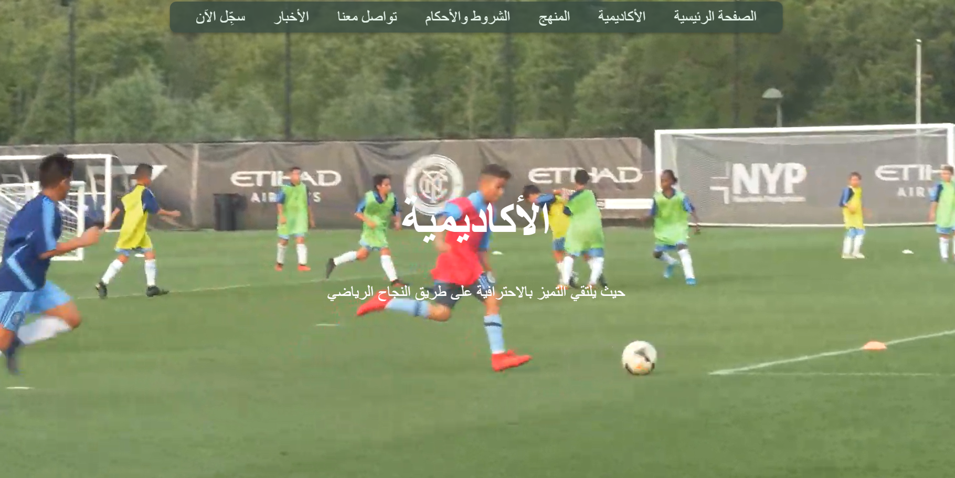  
  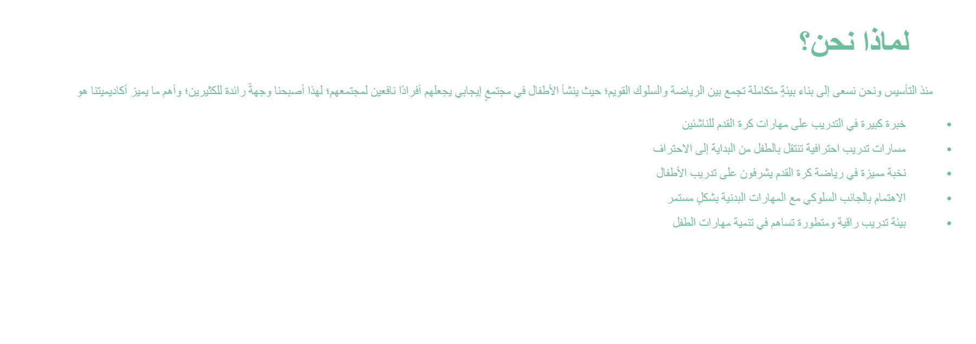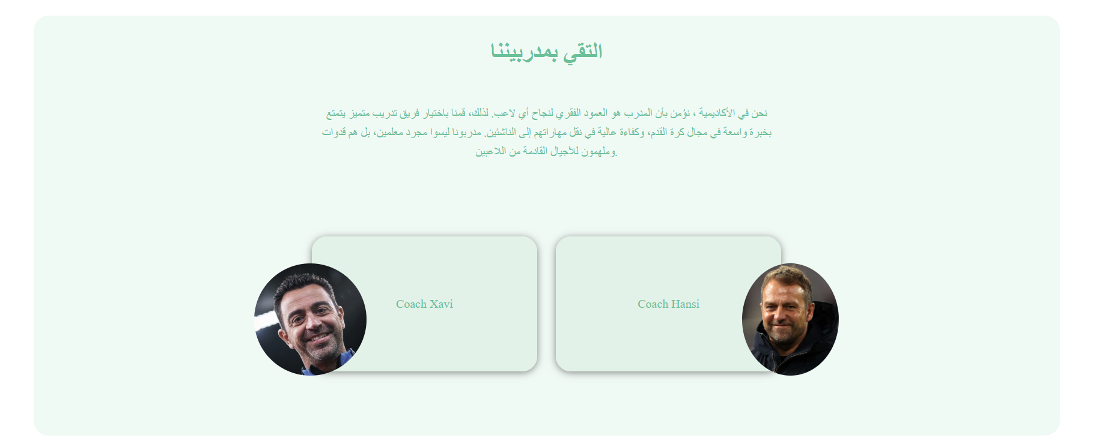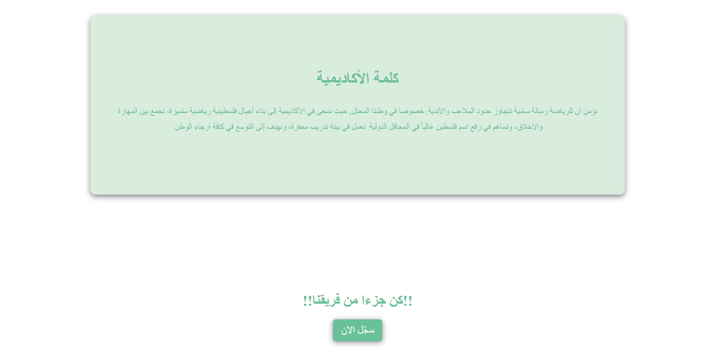and that’s the footer in each page:  
  

2. الأكاديمية

* This page provides detailed information about the academy, including:
* Definition and Goals: Explains what the academy is, its purpose, and the value it aims to provide to participants.
* Advice for Participants: Practical tips and guidelines for trainees to maximize their experience.
* Experience: Highlights the academy’s achievements and track record in training and development.  
    
  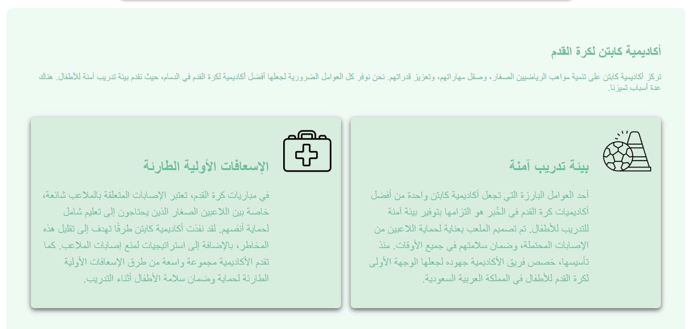  
  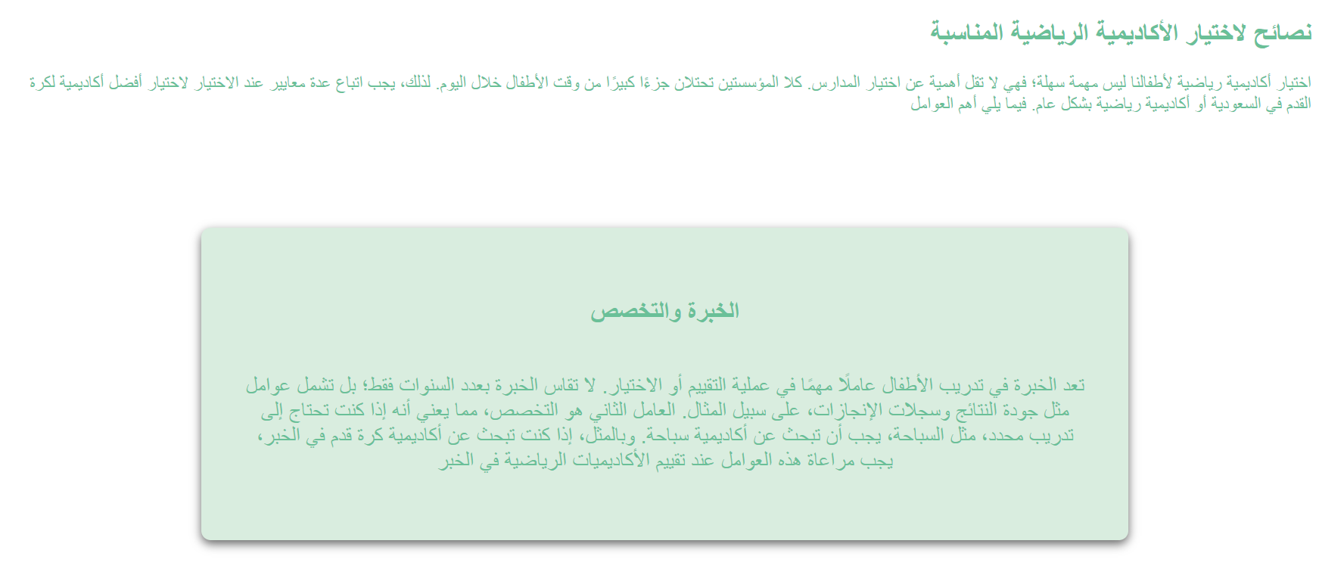

3. المنهج

The curriculum page outlines the academy’s training methodology and areas of focus. It includes tailored approaches for different age groups:

* 7-9 Years: Basic skill development and introductory techniques.
* 10-12 Years: Intermediate skills and building foundational knowledge.
* 13-14 Years: Advanced techniques and strategy development.
* 15-17 Years: Professional-level training, preparing participants for competitive performance.  
    
    
  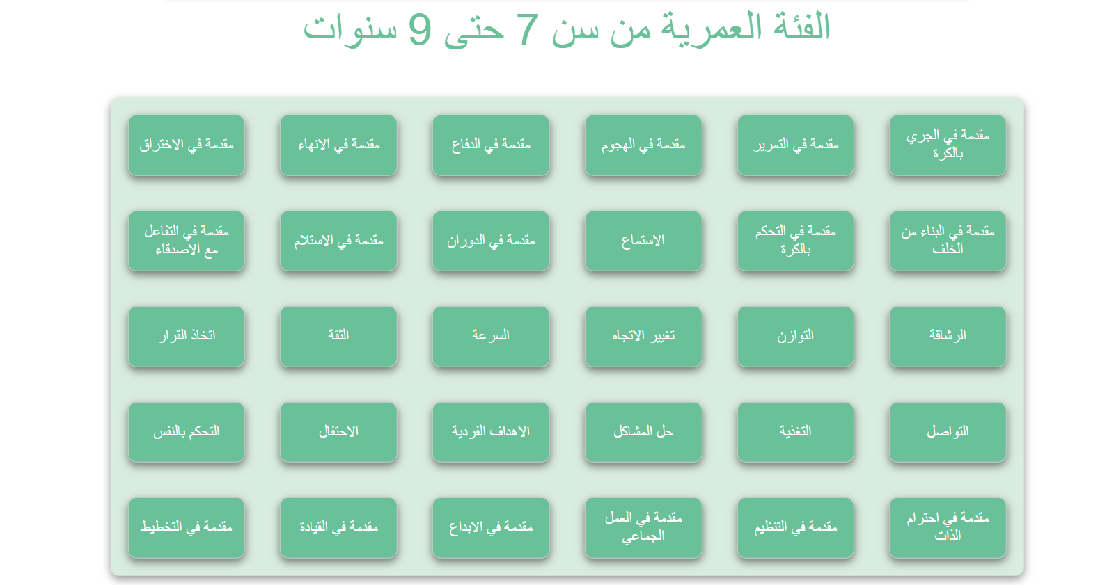  
  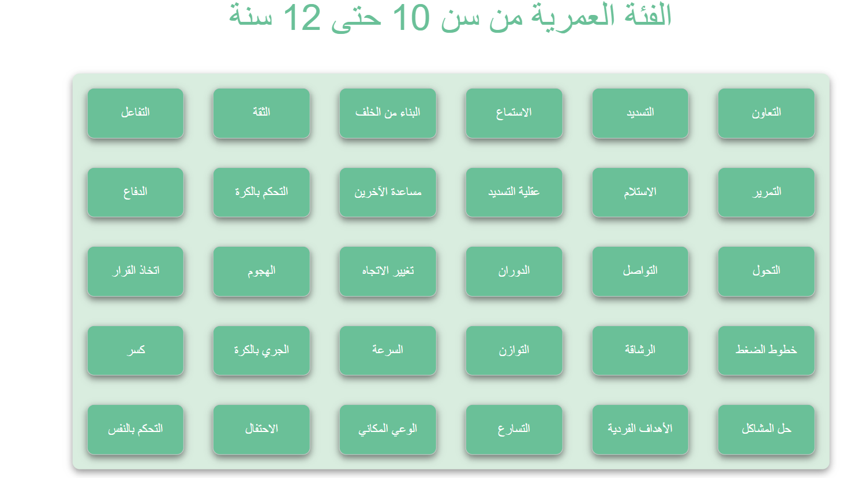  
    
  and the same for else Ages.

4. الشروط والأحكام

This page outlines the terms and conditions for registration, ensuring participants and guardians are informed about:

* The requirements for joining.
* Guidelines and rules to ensure a safe and productive environment.
* Policies for participation, cancellation, and other related matters.  
    
  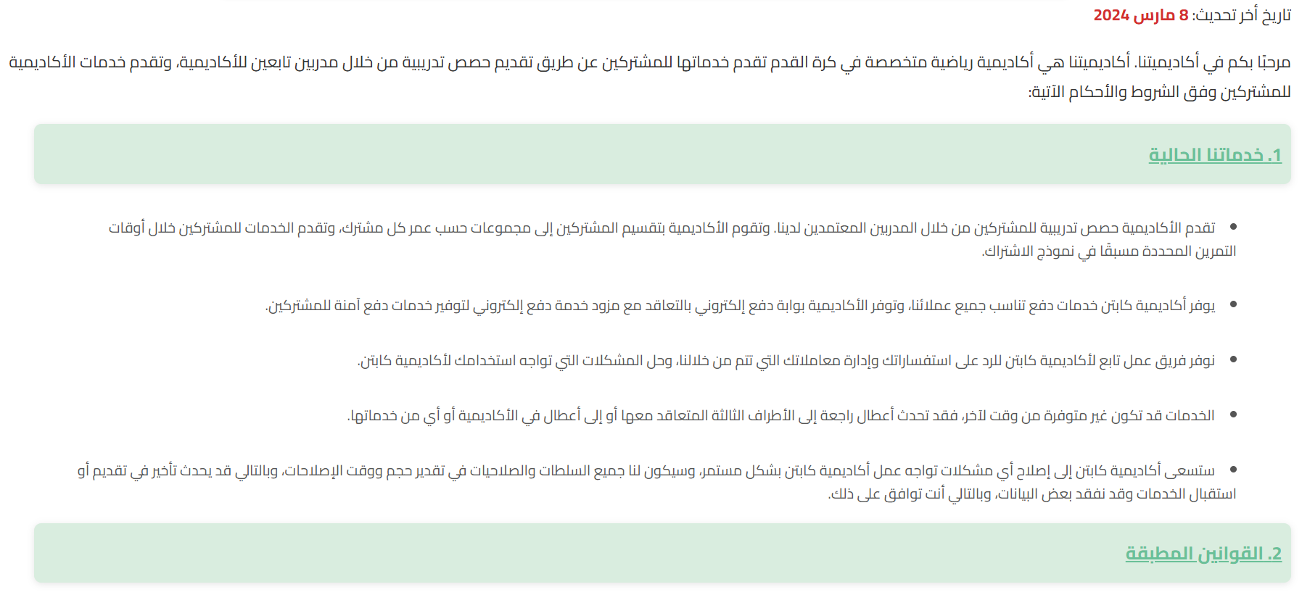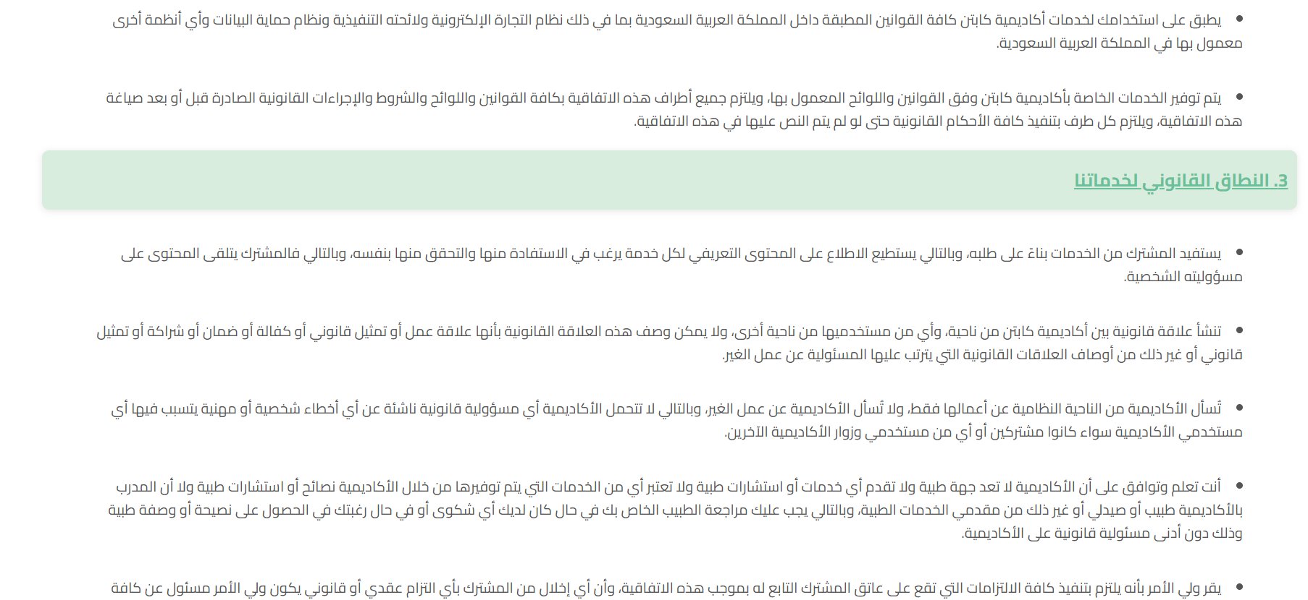  
    
  and all rules…

5. تواصل معنا

This page is dedicated to communication between users and the academy. It allows visitors to:

* Submit inquiries about specific details or services.
* Request support or clarification on academy-related matters. 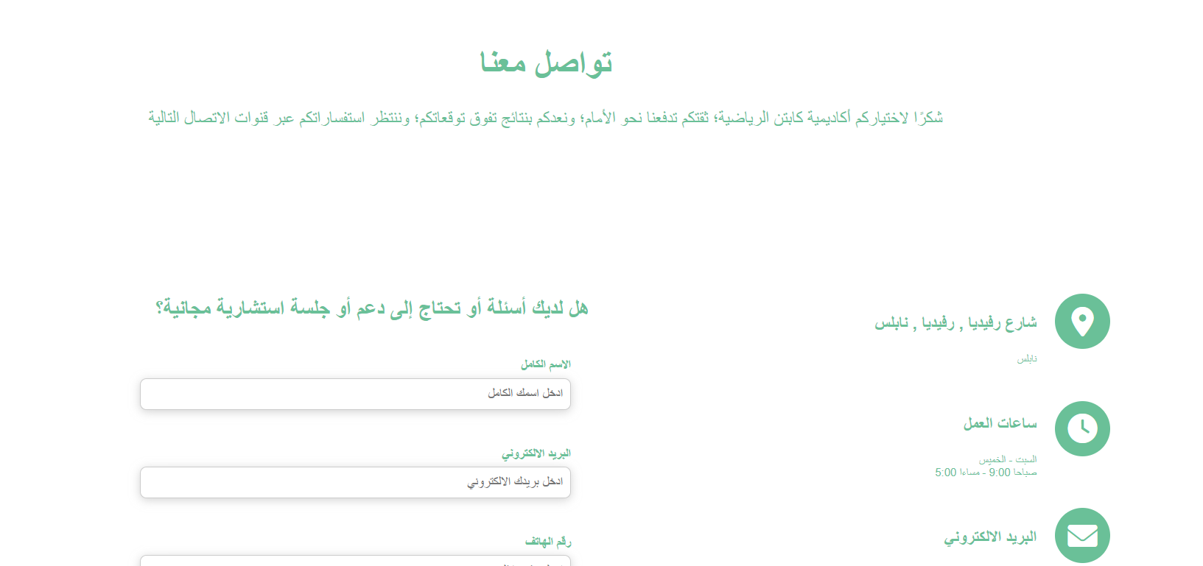

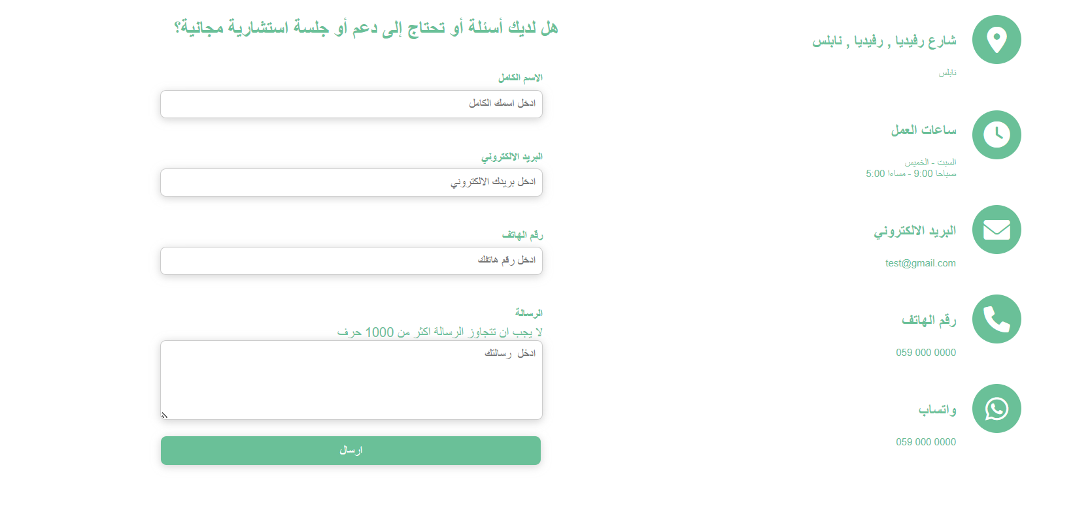

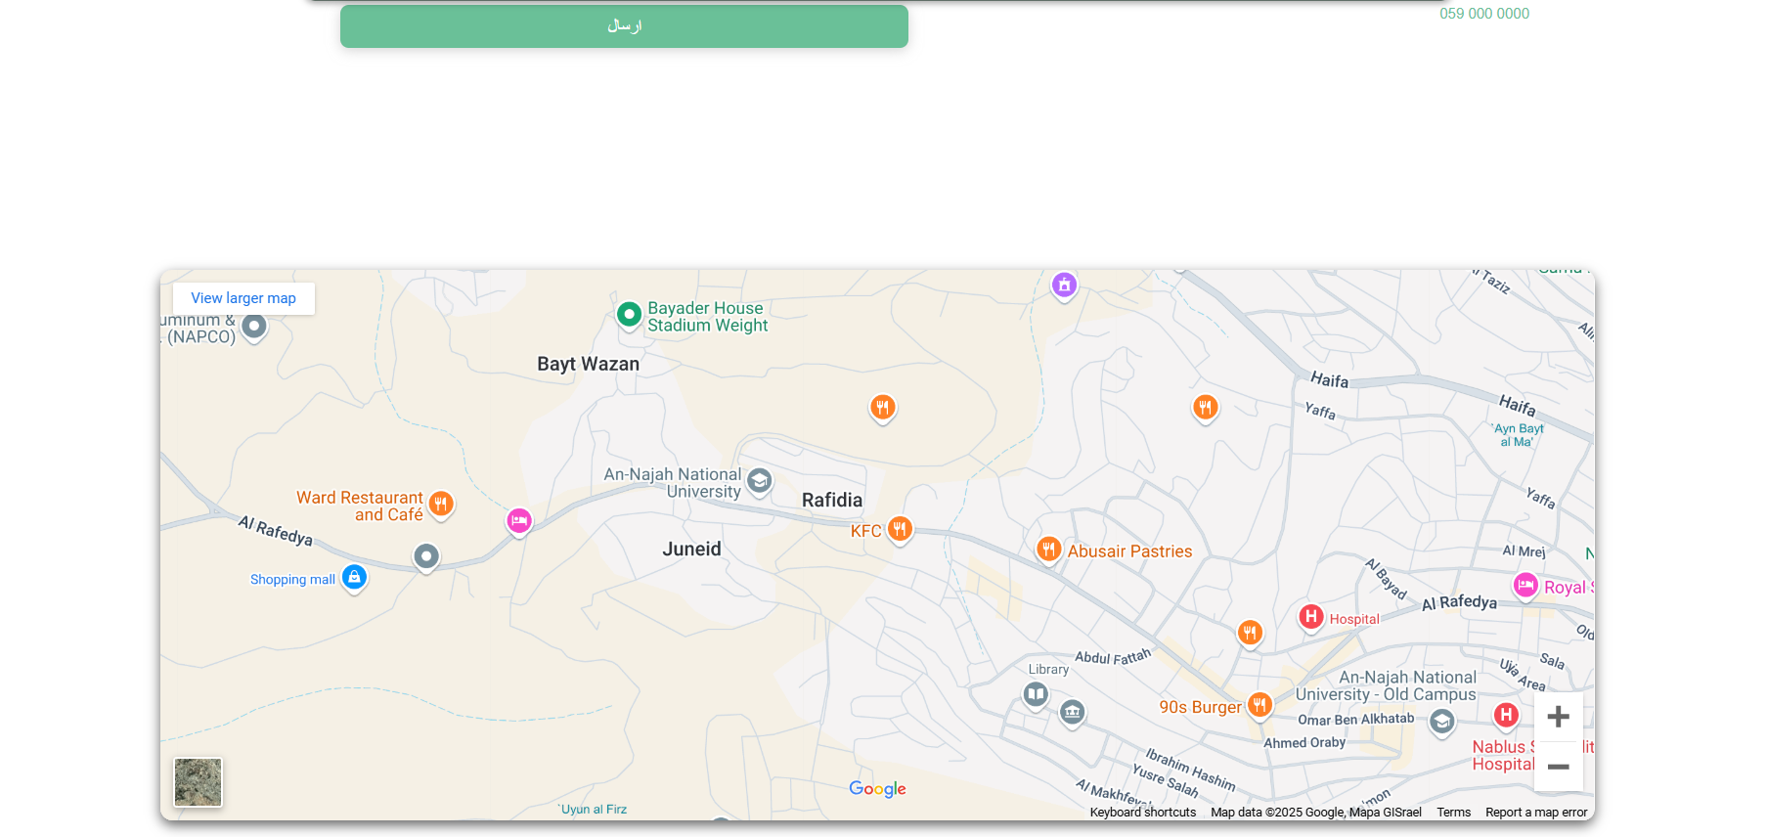

6. الأخبار

This section serves as the academy’s news hub, showcasing:

* Updates on events and activities.
* Photos and highlights from recent meetings and training sessions that you can download it.
* Announcements and other relevant information.

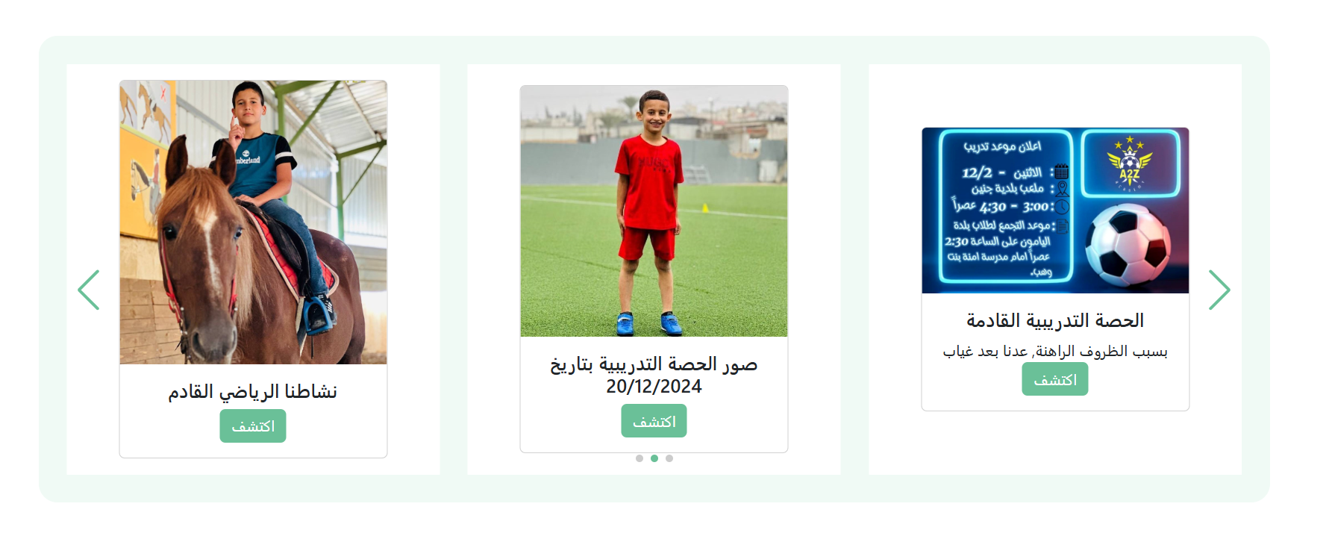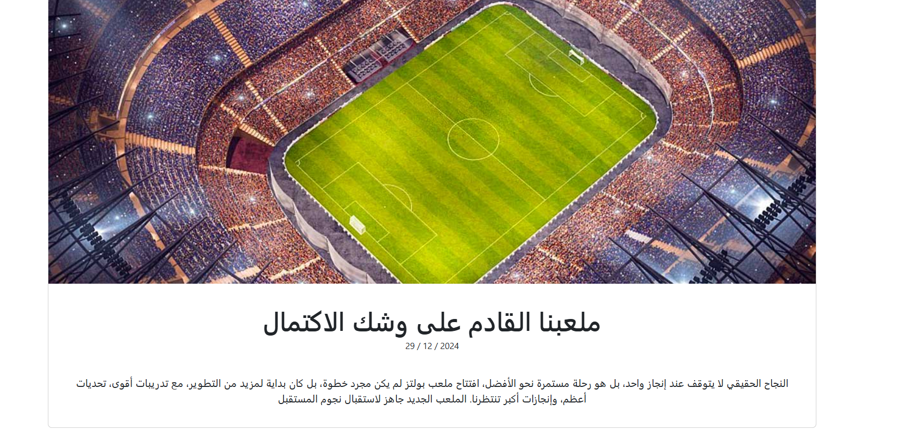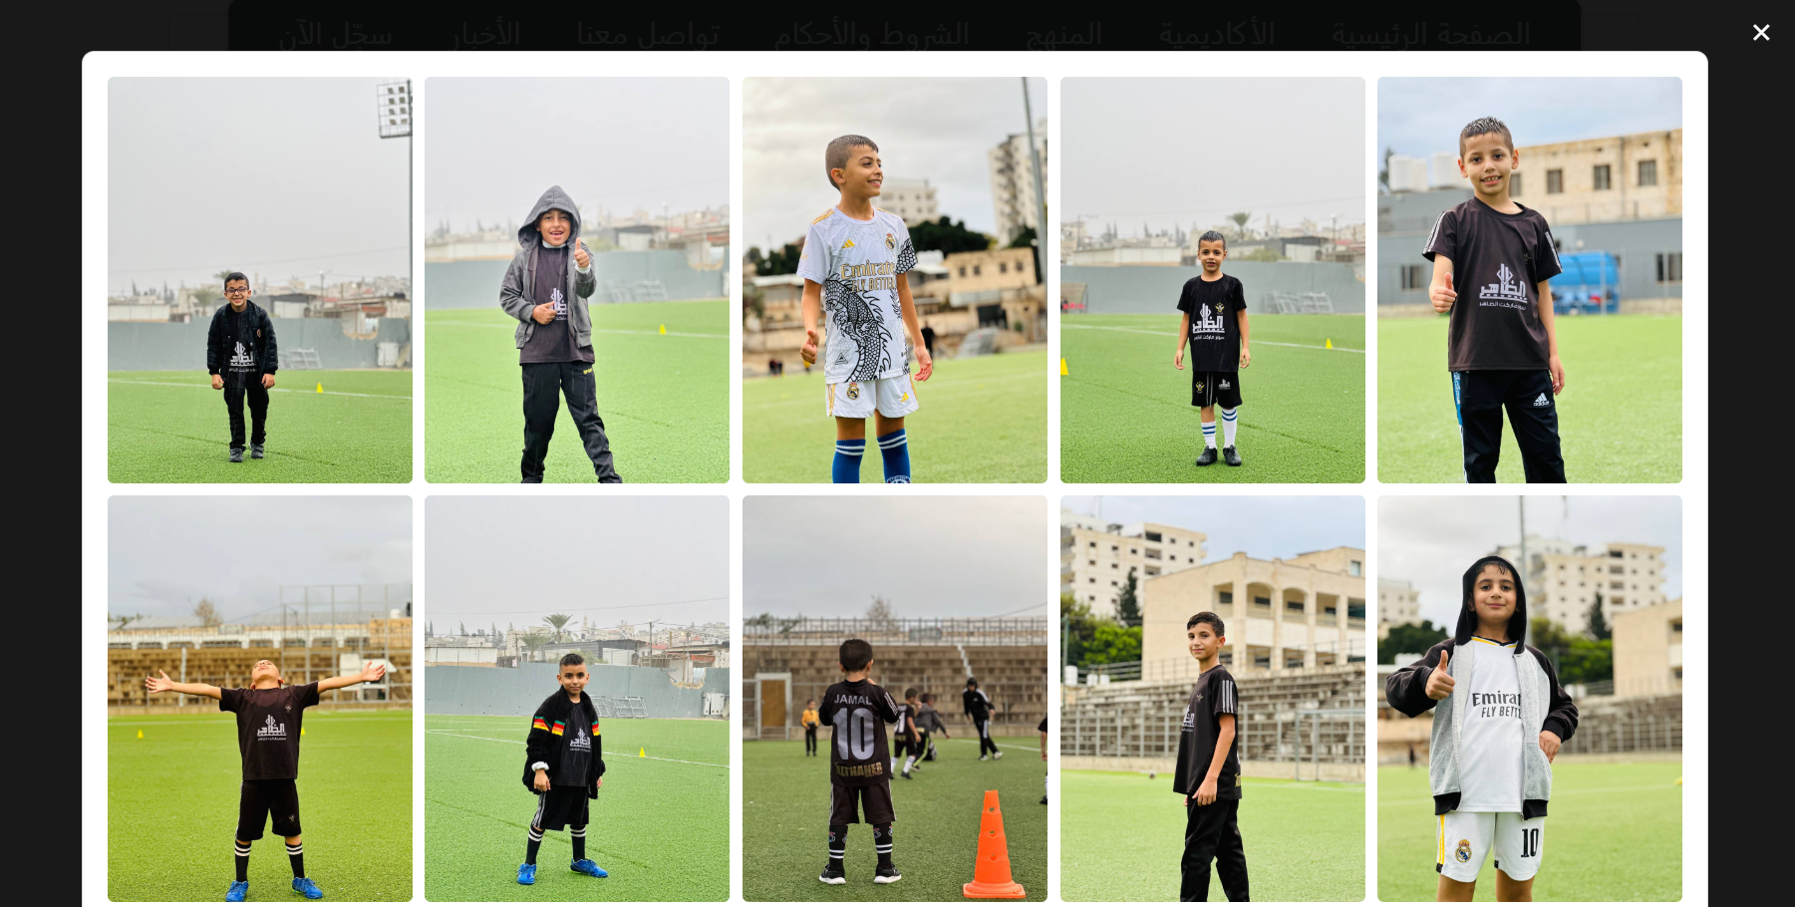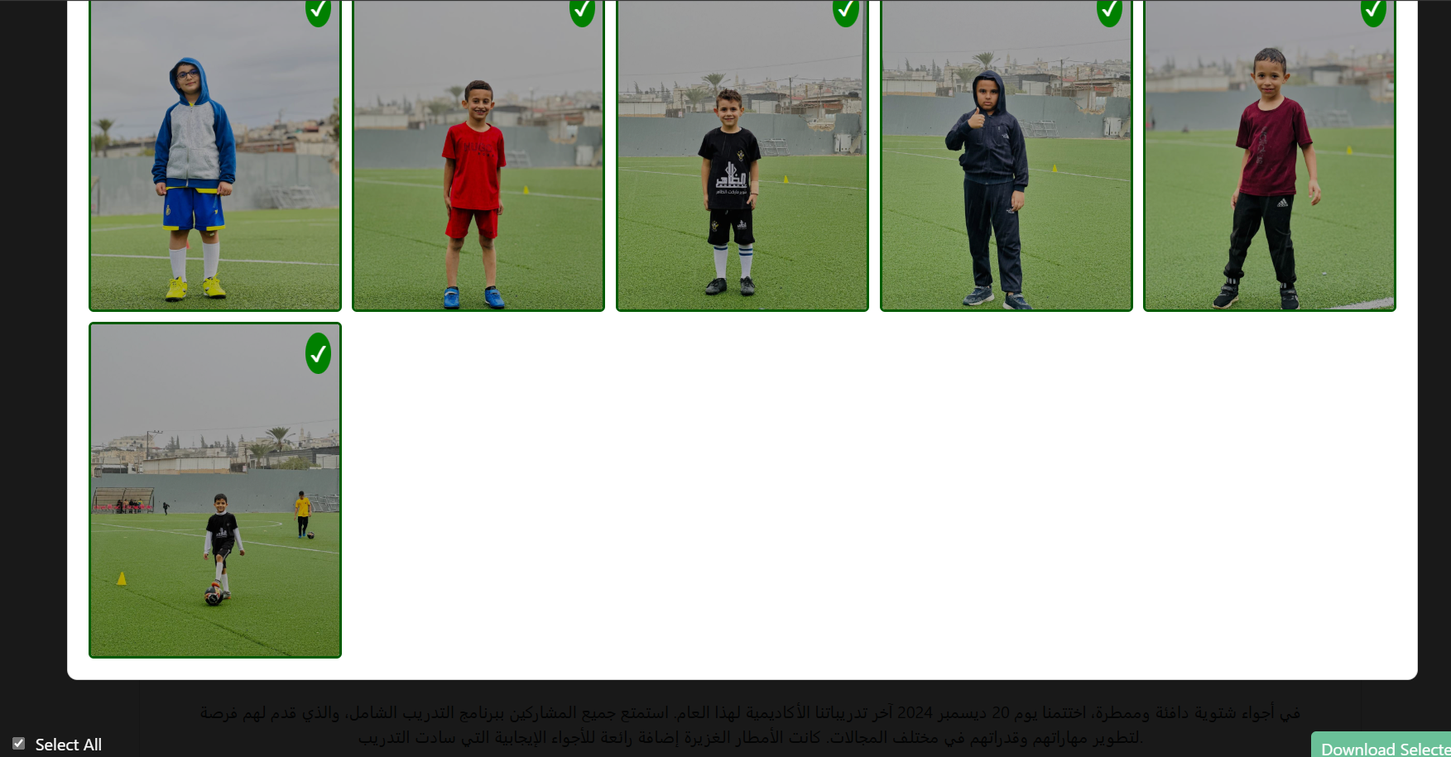

7. سجل الان

The registration page facilitates new account creation and login for existing users. Features include:

* Create a New Account: Enables new participants to sign up for the academy’s programs.
* Login: Allows registered users to access their profiles and additional features, including notifications.  
    
  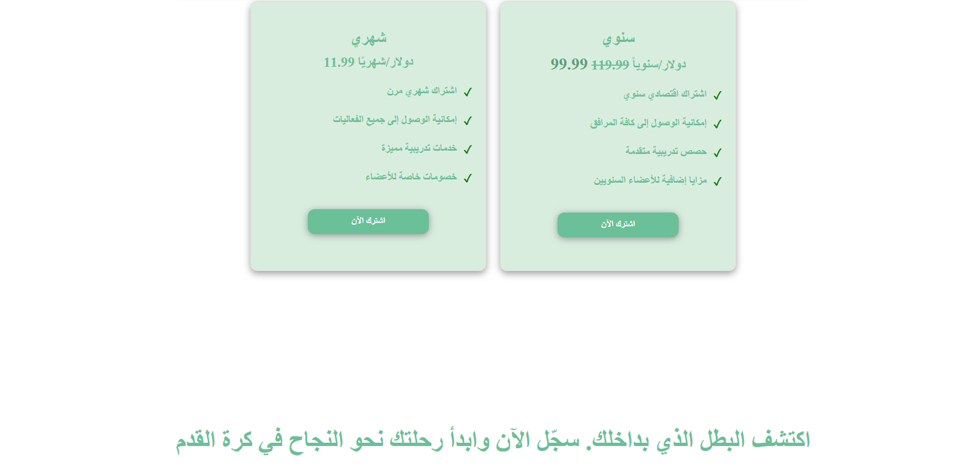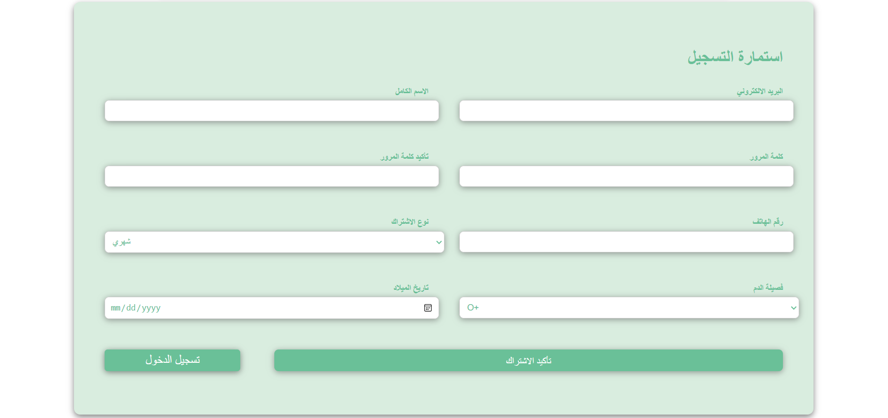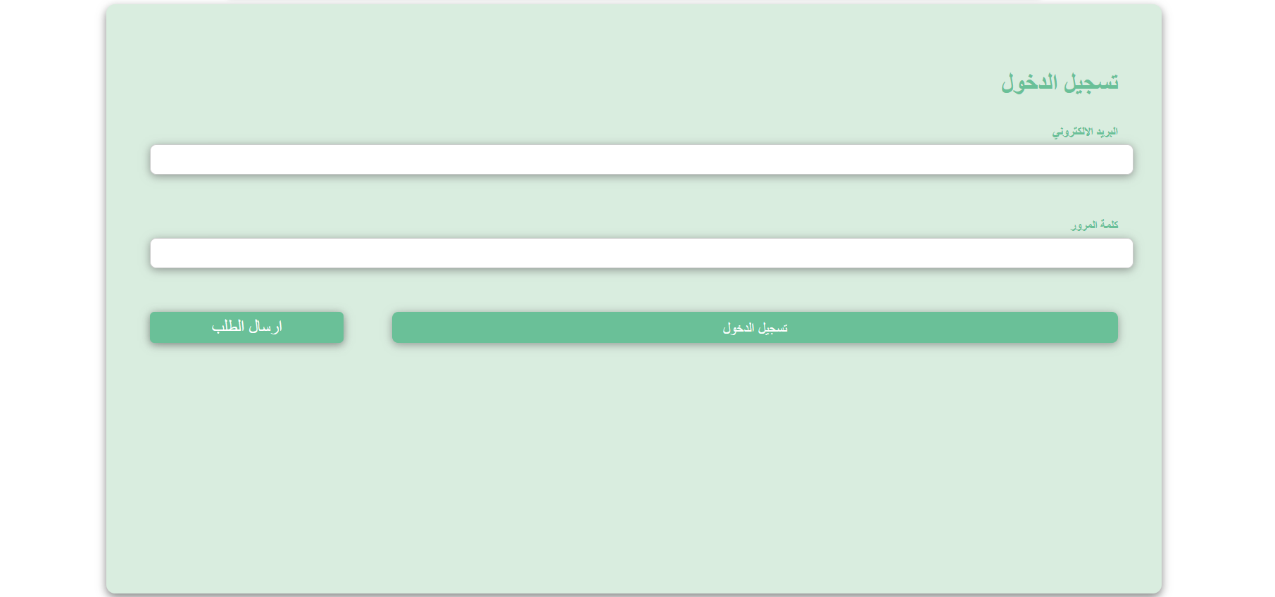

8.لوحة القيادة

The Dashboard serves as the main location where users may control their platform activity and receive crucial information. It is intended to give a brief summary of important metrics, forthcoming occasions, and current undertakings. The elements listed below can be included into the

* Greetings:   
  a customized greeting that uses the user's name to greet them and gives a quick rundown of their current situation (such as their subscription type or forthcoming events).
* Fast Links:   
  shortcuts to commonly used functions, including Contact Support, View Schedule, and View Notifications.

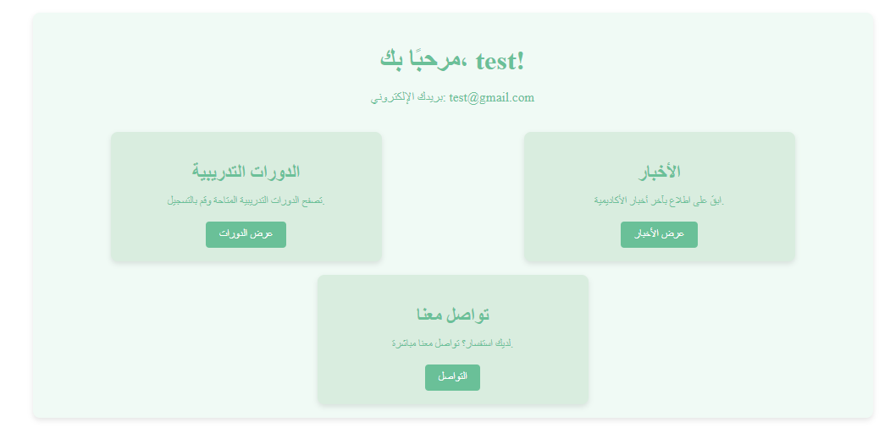

9.قائمة الخيارات

The Options List is a simple, uncluttered menu that gives consumers easy access to key functions. It is intended to be straightforward and effective, concentrating on the most important tasks that users must complete. The two primary choices from the list are as follows:

* Notifications:   
  With this option, users may see all of the alerts that the system or academy have issued. Updates on training schedules, significant announcements, or messages from trainers are examples of notifications.
* Individuals can:   
  View Unread Notifications: Shows a list of alerts that haven't been read yet.
* Mark as Read: This feature enables users to categorize their inbox by marking particular alerts as read.
* Exit the session:   
  With this option, users may safely log out of their accounts. It guarantees that the user's session is appropriately ended, shielding their account from unwanted access.   
  The user can sign in again if necessary after clicking, which will take them to the login screen.

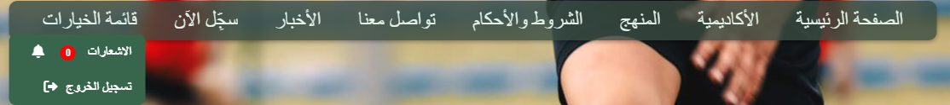

**Tools**

1- This tool named **visual studio code**, and it's the most important tool in our website   
because it's a compiler to build the project by code like “**Code builds our website, and Visual Studio Code is the key.**”



2- **XAMPP ,** this tool simply a web server put the project on LAN server to make many people Access it in the same time



3- The next tool aren’t tool physically because it exists inside visual studio code but its very important to build our project ,

because it's the “code” or the project how looks inside.

-First **“HTML”**

HTML is the standard markup language for creating Web pages.

-Second **”CSS”**

CSS is the language we use to style a Web page.

-Third **” JavaScript”**

JavaScript is a scripting or programming language that allows you to implement complex features on web pages

These 3 languages below is complement each other



-Fourth **"PHP"** simple a code is executed on the server.

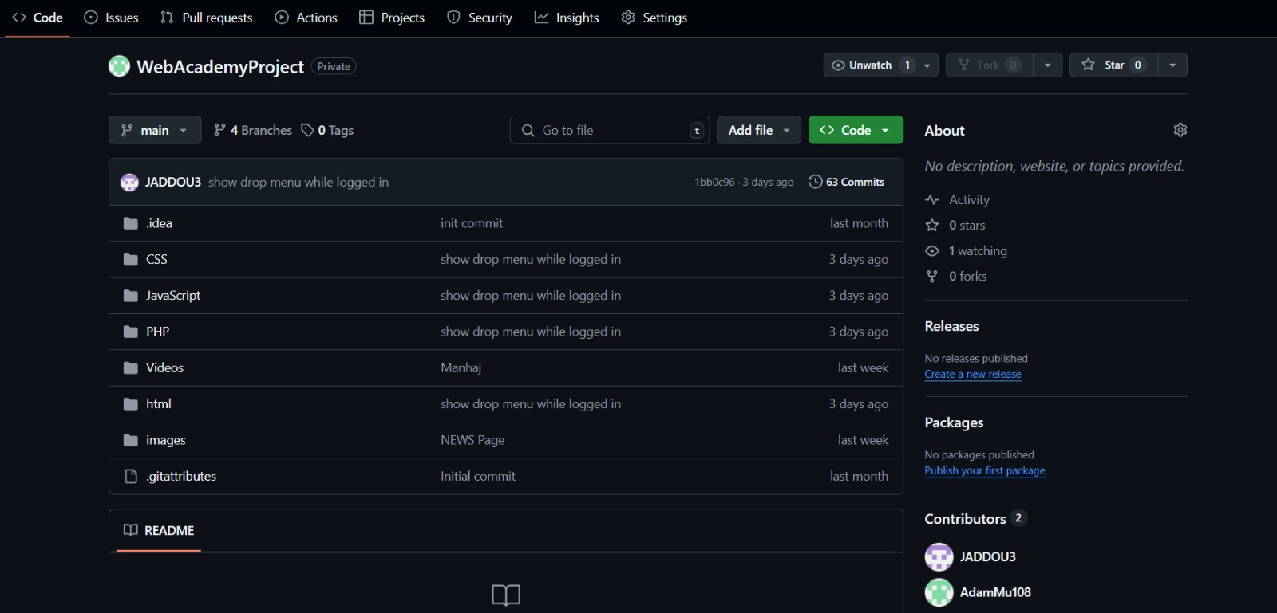4- We have used Github to share the files and page, we have created our own private repository :

 

5- the last one was **a "MySQL”** ,a relational database management system (RDBMS) developed by Oracle that is based on structured query language (SQL).

**UML**

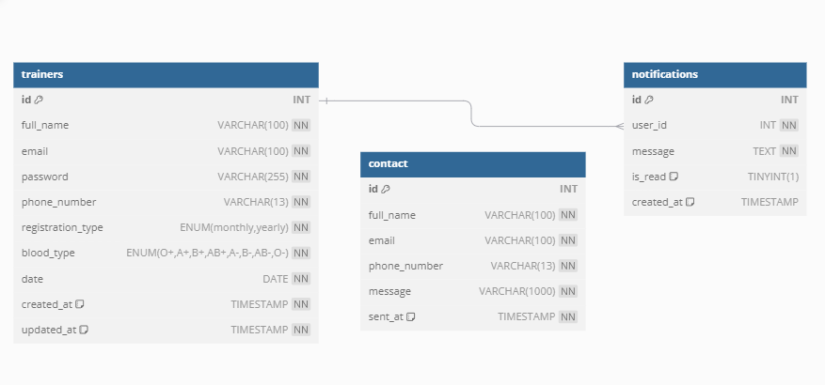

**Conclusion**

In conclusion, this project showcases the creation of a dynamic and user-friendly web platform tailored to the needs of a sports academy. By incorporating detailed information about the academy’s goals, training methodologies, and achievements, the platform serves as both an informative resource and an operational tool.

The inclusion of essential pages such as the homepage, curriculum, terms and conditions, contact options, and news updates ensures a holistic approach to user engagement. Furthermore, features like account registration and personalized notifications enhance the overall user experience by providing accessibility and convenience.

This platform not only reflects the academy’s commitment to fostering talent and providing structured training but also emphasizes transparency, communication, and community engagement. It is a significant step forward in leveraging technology to support the academy’s mission of inspiring and developing future athletes.

**References**

* **Web Programming Slides.**
* **w3schools.**
* **Bootstrap.**
* **ChatGPT.**
* **Youtube.**